
CSO/CBO Activity/Monthly Report Format

Type of report: | End of Activity √  Date: 29/07/2025 | End of Month  Month…. July/Year: 2025
Submission details | Date of Submission to SR:  5/08/2025 | Dates received by SR :  __ /___ /______
Name of CSO/CBO: | KALANGALA DISTRICT NGO FORUM - KADINGO | District: KALANGALA
Name of the Subrecipient (SR) | UGANGA HARM REDUCTION NETWORK (UNRN)
Executive summary
- Name of the Activitie(s): Refer to activity in the Budget/Concept.
Activity 1.1: Conduct courtesy calls led by ED and KADINGO Team to targeted key Kalangala District Offices to introduce the project.

- Background to the activity:
Brief Description of the Activity (Max of three paragraphs about the problem the activity is addressing, why the activity is important? How will it will address the problem? Describe the location where the activity was implemented (Subcounty, parish, Village as applicable and target population)

The activity was aiming at increasing coordination, building relationships, and soliciting for support and commitment during project implementation. The activity was addressing a problem of poor coordination/collaboration and ownership among stakeholders specifically the district leadership. It was important in order to strengthen and improve collaboration, coordination, transparency and stakeholder’s ownership of the project. It was addressed through courtesy calls to increase cooperation to different 8 targeted district / sub county leadership offices i.e. 4 at the district (DHO, DCDO, LCV, RDC) and 4 at sub county (LCIII C/P, Sub County Chief, CDO and GISO) for engagement, information sharing and alignment with other district activities in order to provide an enabling environment for improved and effective implementation, visibility and enhanced sustainability of the project.

The project was implemented at Kalangala District offices and Bujumba sub county headquarters, 4 offices at the district were visited which included DHO, DCDO, LCV, RDC and 2 offices at sub county LCIII C/P, and CDO respectively in order to understand their priorities / concerns and support towards the project .

- Objectives of the Activity:
These are statement(s) that explain the reasoning behind an activity or the aim e.g. what you ought to achieve after implementation of this activity (end results
- To increase awareness of integrated TB prevention and care services among fishing communities at landing sites in Bujumba Sub-county, Kalangala District by end of December, 2025.
- To improve collaboration and enabling environment for effective project implementation, visibility and sustained local support.

- Methodology of Implementation (Describe how the activity was implemented, Implementers involved and steps involved from beginning to end, resources used. Basically, the approaches used to implement the activities(s)).
- The courtesy call activity was implemented by a team of three KADINGO staff led by the Executive Director as the first and entry activity under the TB awareness, Prevention and treatment project. The team began by a planning meeting for the activity, prepared official letters of introduction and printing/photocopied copies of the project concept note, which outlined the project’s objectives, key activities, and expected outcomes for distribution to the key offices. Appointments were then scheduled in advance with 4 key targeted District offices which included the DHO, DCDO, LCV and RDC’s office and 4 at Sub-county including LC III C/P, Sub-county chief, CDO, GISO.
- During each visit, the team formally introduced themselves and the organization, introduced the TB awareness project in details, and provided printed copies of the approved concept note for the officials’ reference and engaged the officials in discussions on the approved project and strategies proposed to reduce TB in Bujumba Sub County to strengthen collaboration and improve coordination among stakeholders, encourage ownership, transparent and visibility for effective and successful implementation of the project. The Executive Director led the orientation discussions, highlighting the importance of local leadership involvement and seeking their support and commitment. The officials were encouraged to ask questions and share their views, and all feedback and recommendations documented with a request to take photos for accountability purposes. The visits were concluded with expressions of appreciation and a commitment to continued engagement throughout the project period.

- Achievements/Results obtained ((where possible include photos that depict an activity going (see format provide), Include Quantitative summaries in a format of your choice as per indicators listed in the excel template))

- Stakeholder Engagement Initiated: KADINGO successfully introduced the TB Project to key district and sub-county leaders, laying the foundation for future collaboration.
- Supportive Leadership: Leaders who were available expressed willingness to support and guide the project within their areas of jurisdiction.
- Visibility and Awareness Raised: The courtesy calls raised awareness about the project goal and the role of local leadership in supporting TB interventions.
- Contacts Established: KADINGO team managed to establish direct communication lines with key offices, enabling future follow-up and coordination.
- Positive Reception: The initiative was generally and generously received with leaders acknowledging the relevance of addressing TB in the community and thanked KADINGO for the efforts in lobbying for funds in line with TB activities.
- Target: KADINGO team managed to visit 6 offices, with a total number of 7 participants that included 5 males at the district and 2 (1male and 1 female) at the sub county.

Pictorial Presentation
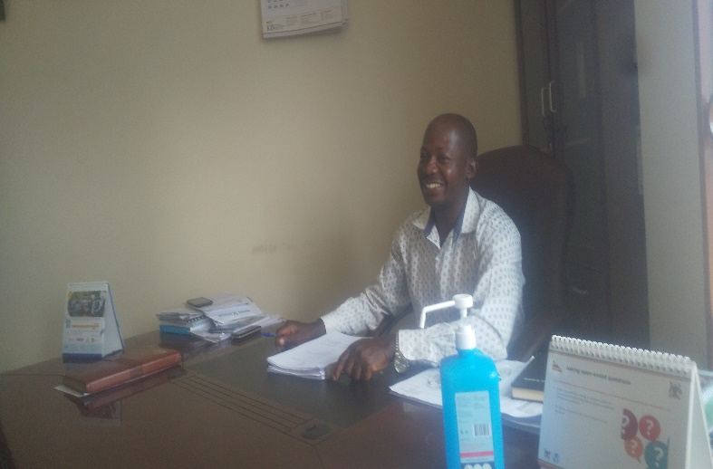
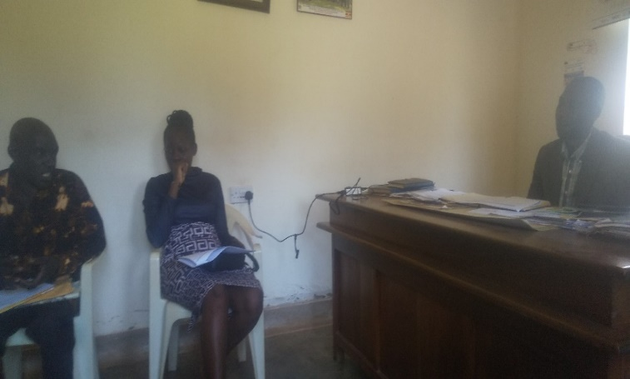
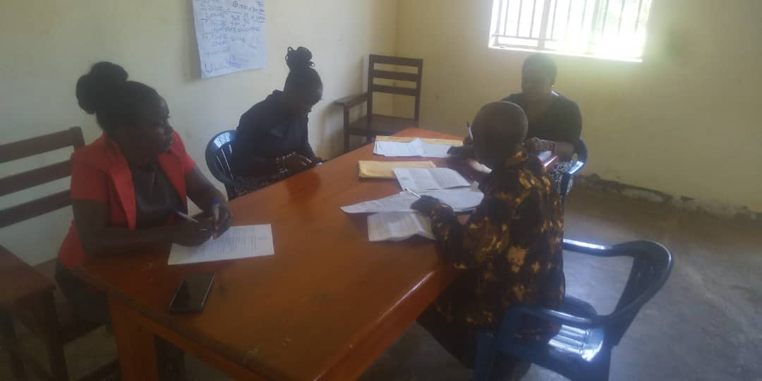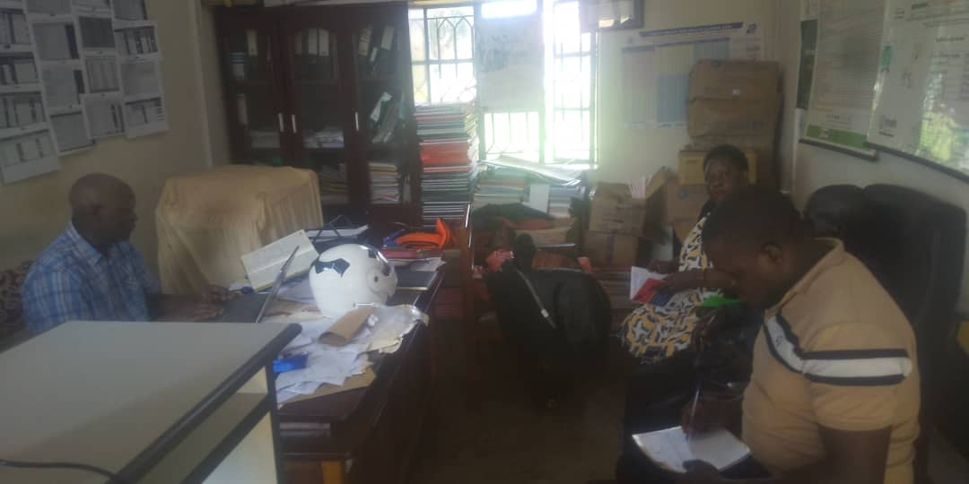
Figure 5: KALANGALA DISTRICT LC V Mr. Ssemukala Rajabi appreciating KADINGO team for lobbying funds under TB awareness which is always left out whereas it moves together with HIV during the courtesy call.to introduce project
Figure 2 KADINGO courtesy call to LC III Mr. Peter Ssenyanja to introduce TB awareness project in Biujumba Sub County.
Figure 3: KADINGO meeting the CDO Ms. Kisakye Esther to introduce TB project for integration with other activities in Bujumba county
Figure 4: KADINGO team meeting the DHO representative Mr. Simon Kawese the Bio Statistician during a courtesy call to introduce projecT
Figure 7: KADINGO team introducing and discussing the TB awareness project with DCDO representative Mr. Willy Nkumbi.
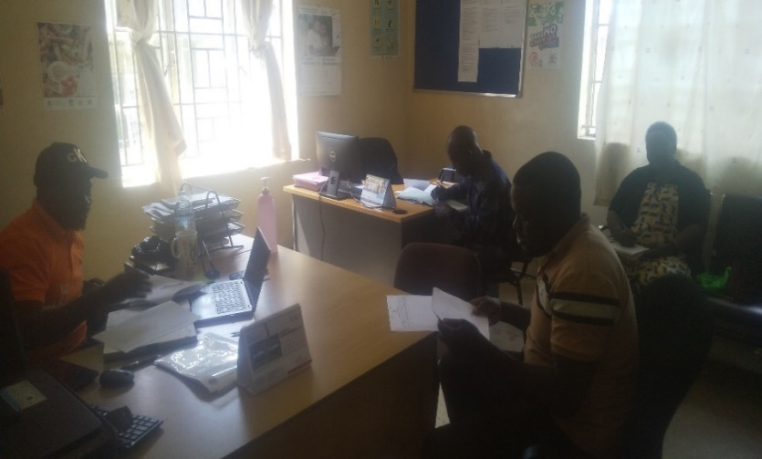
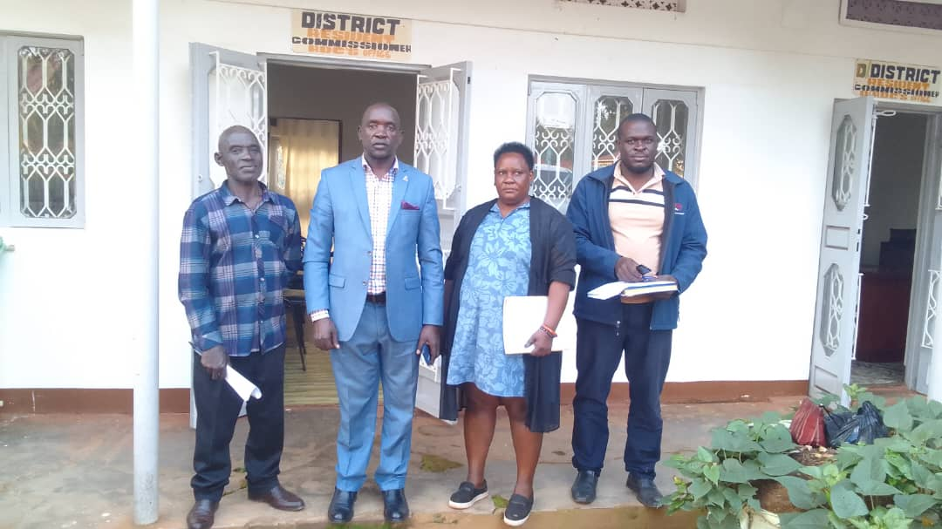
Figure 8: KADINGO team posing with the RDC Kalangala Mr. Badda Fred after the meeting to introduce TB awareness project in Bujumba County

- Challenges encountered during implementation

- Leader Availability: Some targeted leaders had limited time and were unavailable due to conflicting engagements and programs making it difficult to secure a meeting with them.
- Time Constraints: In some meetings, time allocated was not enough to discuss the full scope of the project due to emergencies that took precedence.
- Limited Representation: In a few cases, junior officers or assistants attended on behalf of the intended officials, leading to delayed decisions and commitments.
- Logistical challenges in terms of transport, Travelling to district offices several times arranging and seeking appointments for meetings which were not honored by some officials thus making us implement the activity in two days instead of 1day which was budgeted for making it time consuming.

- Lessons Learnt (Statements about the good practices or what worked well/didn’t work well in the
Process of implementing the activity)

- Tight schedules of leaders: Local leaders often have busy and unpredictable schedules, requiring flexible planning for engagements.
- Advance Notice Improves availability and attendance: Leaders and other stakeholders are more likely to attend meetings when given sufficient notice, agenda and follow-up reminders.
- One-on-One engagement Works: Personalized or smaller group engagements proved more effective than expecting large meetings with multiple leaders.
- Having clear communication is paramount: Having a concise, well prepared message /concept helped in gaining attention and immediate understanding of the project’s importance.

- Recommendations for performance improvement
- Need for timely reviews and feedback to discuss the project objectives, benefits, emerging issues and potential impact to the district for performance improvement
- Follow up meetings should involve the key officers engaged previously, the implementation team and selected clients / beneficiaries to represent respective communities.

- Strategies for the next activities

- Schedule Meetings in Advance: Engage offices early with formal written communication, calls, and follow-up visits to book
- Timing and location: Time is a key factor while we plan for our meetings for example the convenient time for the participants and punctuality.
- Use of Local influencers: KADINGO team to Identify local influencers to assist in coordinating meetings and reminding leaders.
- Prepare Brief Informational Materials: Share briefing notes and agenda outlining the purpose of meeting that leaders can review even in case of missed meetings.
- Flexible time: Consider holding meetings during hours that do not conflict with peak administrative duties, or other daily schedules of participants.
- Conduct Follow-up Visits: For those who were not available, KADINGO team will plan for targeted follow-up courtesy visits with a more tailored approach.

REVIEWS/ APPROVALS
CSO/CBO Level

1.Prepared by: SSemugenyi Sylivester | Title: M & E/ project officer | Date: 05/09/2025 | Signature
2. Approved by: TAAKA ROSEMARY EDITH | Title: EXECUTIVE DIRECTOR | Date: 05/09/2025 | Signature 
Sub-recipient level

- Reviewed by: Title: Date: Signature

- Approved by: Title: Date: Signature

Comments and decision by the SR.
8

