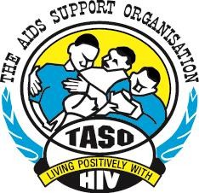
CSO/CBO Activity/Monthly Report Format

Type of report: | End of Activity √  Dates : 30/07/2025 | End of Month  Month…. Year -
Submission details | Date of Submission to SR (dd/mm/yr):  05/08/2025 | Dates received by SR (dd/mm/yr):  / /
Name of CSO/CBO: | KALANGALA DISTRICT NGO FORUM | District: KALANGALA
Name of the Subrecipient (SR) | UGANGA HARM REDUCTION NETWORK  UU
Executive summary
- Name of the Activitie(s): Refer to activity in the Budget/Concept
- Activity 1.2: Conduct orientation of the project implementation team.

- Background to the activity:
Brief Description of the Activity (Max of three paragraphs about the problem the activity is addressing, why the activity is important? How will it will address the problem? Describe the location where the activity was implemented (Sub county, parish, Village as applicable and target population)

- The orientation of the project implementation team in Bujumba Sub County was designed to respond to the problem of low awareness about TB symptoms, prevention, and treatment, as well as limited community action on malaria prevention and control. TB remains a serious concern, often undetected due to stigma and poor knowledge, while malaria continues to be the leading cause of illness in the district. Engaging Village Health Teams (VHTs), Community Health Extension Workers (CHEWs), cultural leaders, religious leaders, and community influencers is important because these are trusted figures who can effectively pass on health messages, encourage early testing, and influence positive behaviour change at the grass root level.
- This activity was crucial as it created a platform for a coordinated response to TB and malaria at the community level with clear roles and responsibilities. By equipping stakeholders with accurate information, referral skills, and strategies for awareness raising, would help to improve early detection of TB cases, promote treatment adherence, and enhance malaria care practices. The activity also acted as a key step toward reducing the burden of TB and malaria and improving overall health outcomes in Bujumba Sub County, through active participation and engagement that aimed at building support, addressing the prevailing concerns for increased awareness, fostering collaboration and clarifying different roles for the success and sustainability of the project

- The activity was conducted at Dreamland Guest House in Kalangala, Kalangala Town Council, through partnership and collaboration, the identified and oriented participants targeted included health personnel, CHEWS, influencers youth, cultural and religious leaders who would raise awareness about TB symptoms, prevention and treatment at village levels, thus increasing awareness and integrated TB prevention and malaria care services for HIV positive clients in Bujumba Sub County. By the end of the orientation, the participants were expected to have been harnessed with knowledge to address the TB curable and preventive measures to be taken in their Bujumba sub county area of coverage in Kalangala District.

- Objectives of the Activity:
These are statement(s) that explain the reasoning behind an activity or the aim e.g. what you ought to achieve after implementation of this activity (end results

- The objective of the activity was to increase awareness of integrated TB prevention and care services of HIV/AIDS clients among communities of in Kalangala District by the end of December, 2025.

- Methodology of Implementation (Describe how the activity was implemented, Implementers involved and steps involved from beginning to end, resources used. Basically, the approaches used to implement the activities(s)).

- The orientation meeting was conducted through a participatory and interactive approach, combining presentations and practical demonstrations to ensure effective learning and engagement. The session began with prayer and introductions, agreement on the proposed agenda, an overview of the TB project’s objectives, followed by a detailed presentations entitled “KADINGO presentation for Orientation for TB project implementation Team UGA –GCT using visual aids to explain the goals, strategies, and specific roles of VHTs, community health workers, TB focal persons, opinion leaders, and cultural leaders in the implementation process. Participants shared experiences, identified challenges, and proposed practical solutions for community-level TB prevention. Throughout the meeting, facilitators encouraged questions, peer learning, and exchange of local experiences to build a sense of ownership and coordinated action. The session concluded with a joint action planning exercise/ way forward, assigning and proposing key strategies and clear responsibilities and timelines to ensure the smooth and collaborative implementation of the TB project at the community level.

- Achievements/Results obtained ((where possible include photos that depict an activity going (see format provide), Include Quantitative summaries in a format of your choice as per indicators listed in the excel template)
- Established a clear and shared understanding of project goals, objectives and expected outcomes.
- Stakeholders engagement through orientation showed active and fully participation fostering collaboration and buy in for the project.
- Conducive environment and knowledge delivered by the TB focal person increased awareness about the importance of TB awareness and project objectives within the district.
- All targeted participants responded totaling to 13 males and 10 females scoring a total of 23.

Activity in pictures
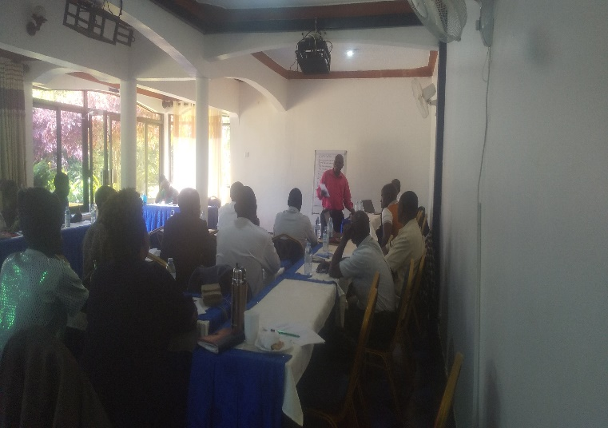
Figure 1: The DCDO Mr. Musaazi Jude giving opening remarks for the orientation meeting of the TB awareness project to the CHEWS/VHTS at Dreamland Guest House
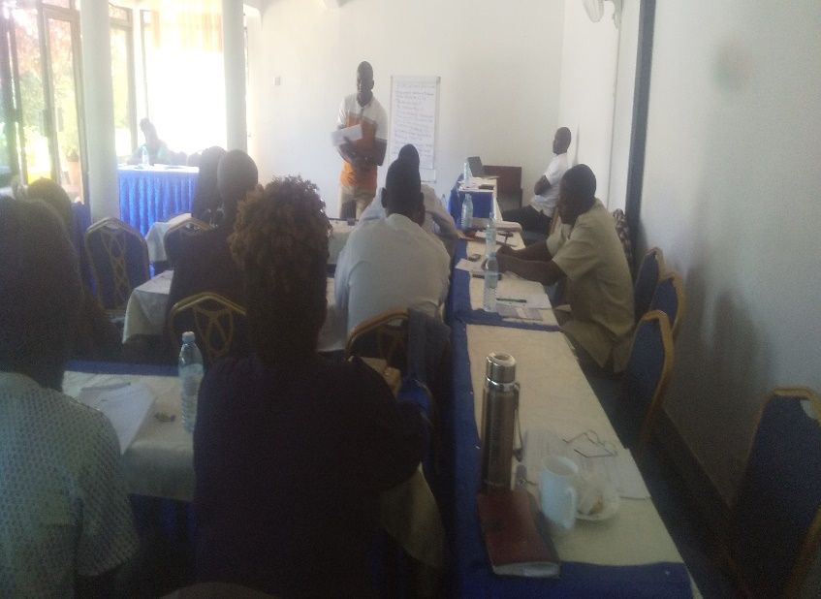
Figure 2: KADINGO Advocacy Officer Mr. Ssenyonga Ibrahim presenting the TB awareness project concept highlighting the objectives, scope, stakeholders involved in the project implementation.
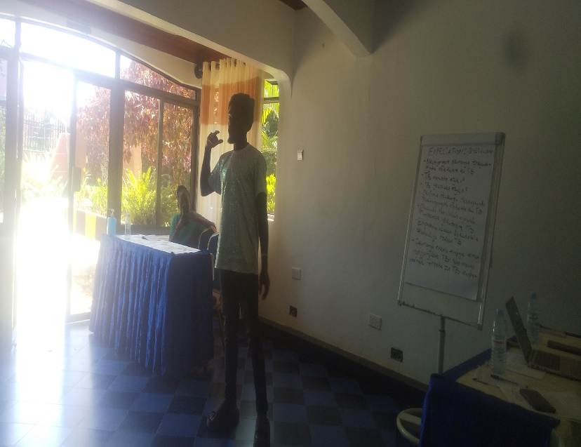
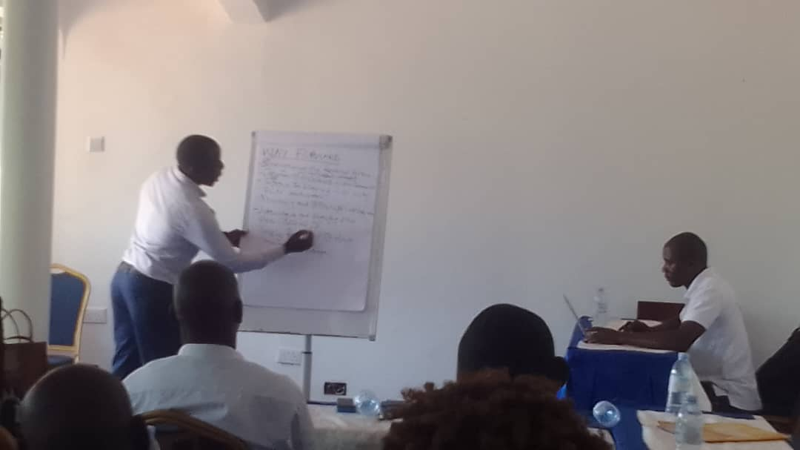
Figure 3: TB champion / client narrating his experience with TB and how it was treated during the orientation meeting

Figure 4: Mr Robert Sebalamu noting down the way forward and Resolutions made for follow up during the orientation meeting
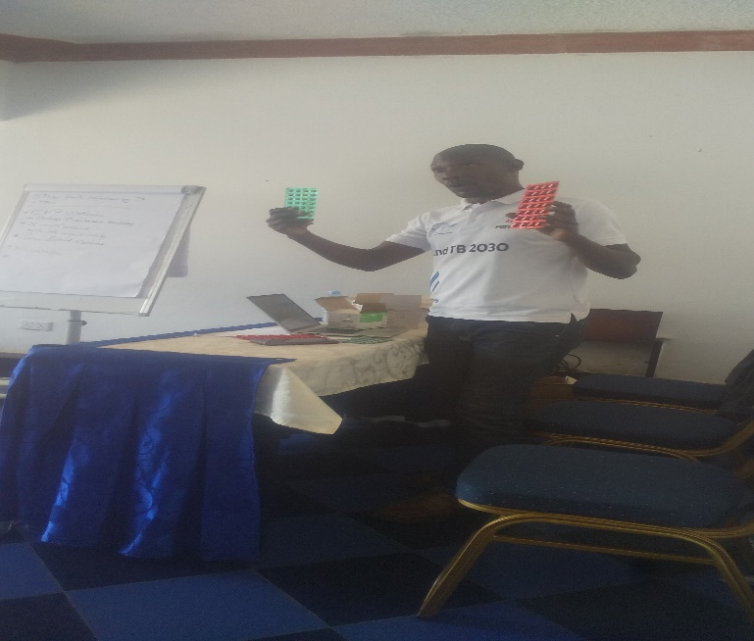
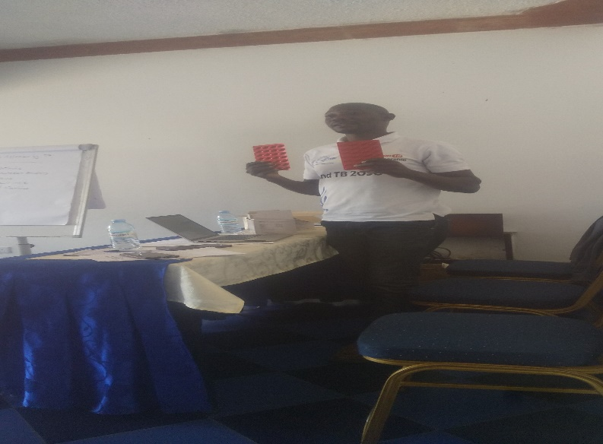
Figure 5: The District TB focal person Mr. Ecric Sserumanga demonstrating to paricipants TB preventive and treatment regimens
Figure 6: The District TB focal person Mr. Ecric Sserumanga demonstrating to paricipants TB preventive and treatment regimens

- Challenges encountered during implementation

- Insufficient funding limited more participants to attend thus limiting effectiveness at grass root level
- Power interrupted the smooth running of the presentation that would have been delivered on the projector.
- Managing stakeholder’s expectations and ensuring they align with the project objectives was very difficult via vie the project total budget. Some had diverse and varying priorities and interests which was not aligned to the project objectives.
- High cost of transport (mainly by use of boda boda) was tabled by participants and couldn’t be addressed by then due to online payments.
- There was limited time that couldn’t allow enough relevant statistical data to be delivered.
- Communication barriers: participants preferred to use the local language Luganda since they were coming from different cultures for easy understanding thus a challenge to the rappouter who was to produce report in English.

- Lessons Learnt (Statements about the good practices or what worked well/didn’t work well in the process of implementing the activity)
- Effective communication is crucial to ensure stakeholders understand the project objectives, goal, and the different roles.
- Collaboration and partnership building will help KADINGO to leverage resources, expertise and influence ultimately enhancing project impact.
- Local context was clearly understand where economic, social and cultural issues were addressed and essential for developing new strategies for improvement.
- Stakeholders were encouraged to give feedback to help KADINGO identify areas of improvement during project implementation for relevance and effectiveness.
- Addressing stakeholders concerns will help KADINGO mitigate potential issues and ensure project success.

- Recommendations for performance improvement
- For performance improvement we do recommend engagement of local stakeholders including community leaders, healthcare providers and local implementers to ensure the project local context.
- Continuous monitoring, spot supervision and evaluation to track progress through establishment of a proper framework
- Use of multiple communication channels like media, community outreaches to reach the targeted population
- Holding regular sensitization and review meetings for sharing of best practices and challenges for purposes of reflecting on the past reviewing the present and transforming the future would be a good practice thus building a good information flow and sharing.

- Strategies for the next activities

- Partnerships and Collaboration through consultation with the project implementation team, prior to the scheduled activities implementation will be of key value and will foster local organizations, healthcare providers and other stakeholders to leverage resources, expertise and influence.
- Capacity building provision through training opportunities for healthcare providers, community workers and other stakeholders to ensure they have stills and knowledge needed.
- Involving people affected by TB in project planning and implementation to ensure that their needs are considered at all levels.
- Continuous monitoring and evaluation to track progress and identify areas of improvement for informed decisions.
- Being flexible and adopt to working conditions of other stakeholders, be willing to adjust in your secluded plans

REVIEWS/ APPROVALS
CSO/CBO Level

1.Prepared by: | Title: | Date: | Signature
2. Approved by: Taaka Rosemary | Title: Executive Director | Date: 04/08/2025 | Signature
Sub-recipient level

- Reviewed by: Title: Date: Signature

- Approved by: Title: Date: Signature

Comments and decision by the SR.

